CREATING A BRANCH
There are two ways to create a ‘Branch’
In Local repository
The command to create new branch - git branch branch-name

Steps to follow:
Right click on the folder and select ‘Open Git Bash here’ (under ‘show more options’),
Type-in git branch to show existing branches
- Make the current folder as main branch using command
git branch -M main
- Connect to remote repository using the command
Git remote add origin link
- Push the files in the folder to remote repository using command
git push -u origin main
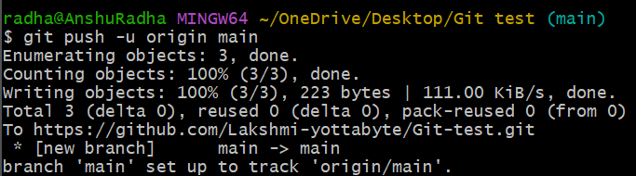
- Create a branch using the command
git branch branch-name
Here branch name is ‘B1’
Check the branches in repository using command
git branch
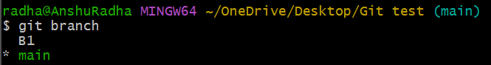

In Remote Repository
- On GitHub, navigate to main  on top left side.
- Select ‘View all branches’ from dropdown menu.
- Click ‘New branch’
- Enter New branch name
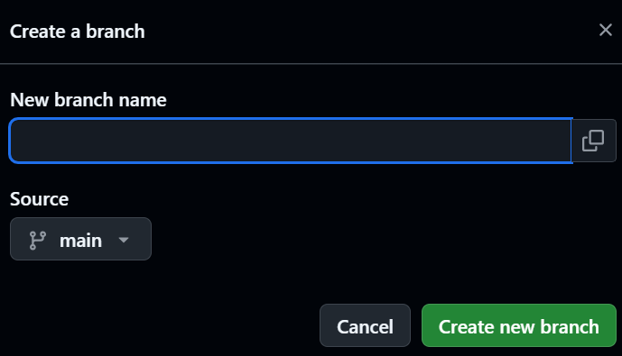
- Click ‘Create new branch’

